Dear Friends,

Gigliotti Holdings cordially invites you to our seventh annual Golf Classic of which 100% of the net proceeds will benefit Children’s Hospital of Pittsburgh Foundation. With your generous contributions and countless hours spent, we have raised almost $500,000 and soon will reach $1,000,000. We personally thank you very much.

This year’s event will again be held at the beautiful Treesdale Country Club, a premier private club in the North Hills of Pittsburgh.

Larry Richert, KDKA personality and Steelers announcer will emcee the event. The Guest Speaker will be Chris Gessner, President of Children's Hospital.

Chinese, silent, and live auctions will be held during the dinner and prize ceremony.

We look forward to seeing you on August 24, 2015, at Treesdale Country Club.

Sincerely, Dominic Gigliotti and family

Welcome to the Gigliotti Holdings Golf Classic!

Gigliotti Holdings

Presents

The Seventh Annual

Gigliotti Holdings

11279 Perry Highway, Suite 509

Wexford, PA 15090

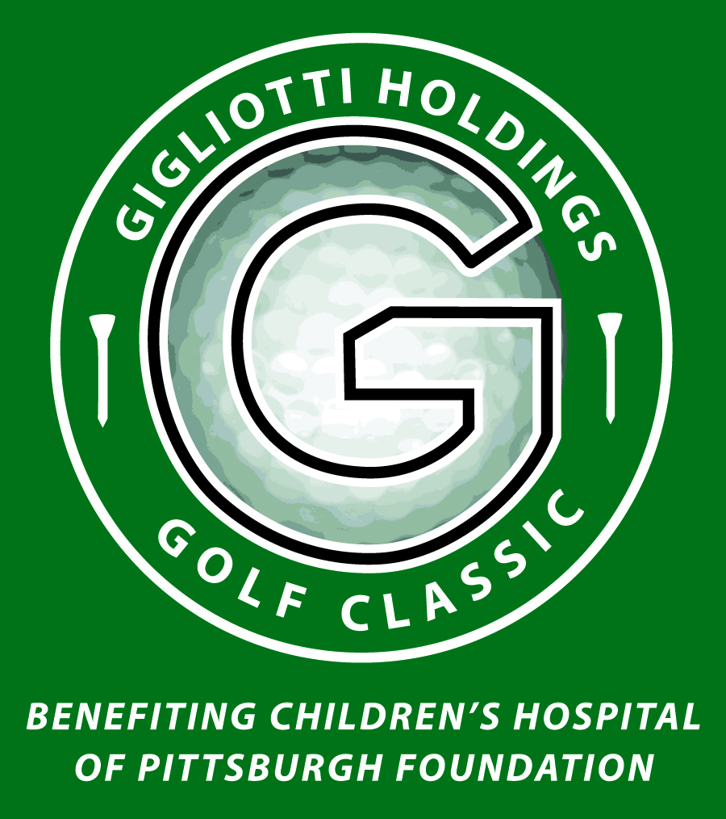

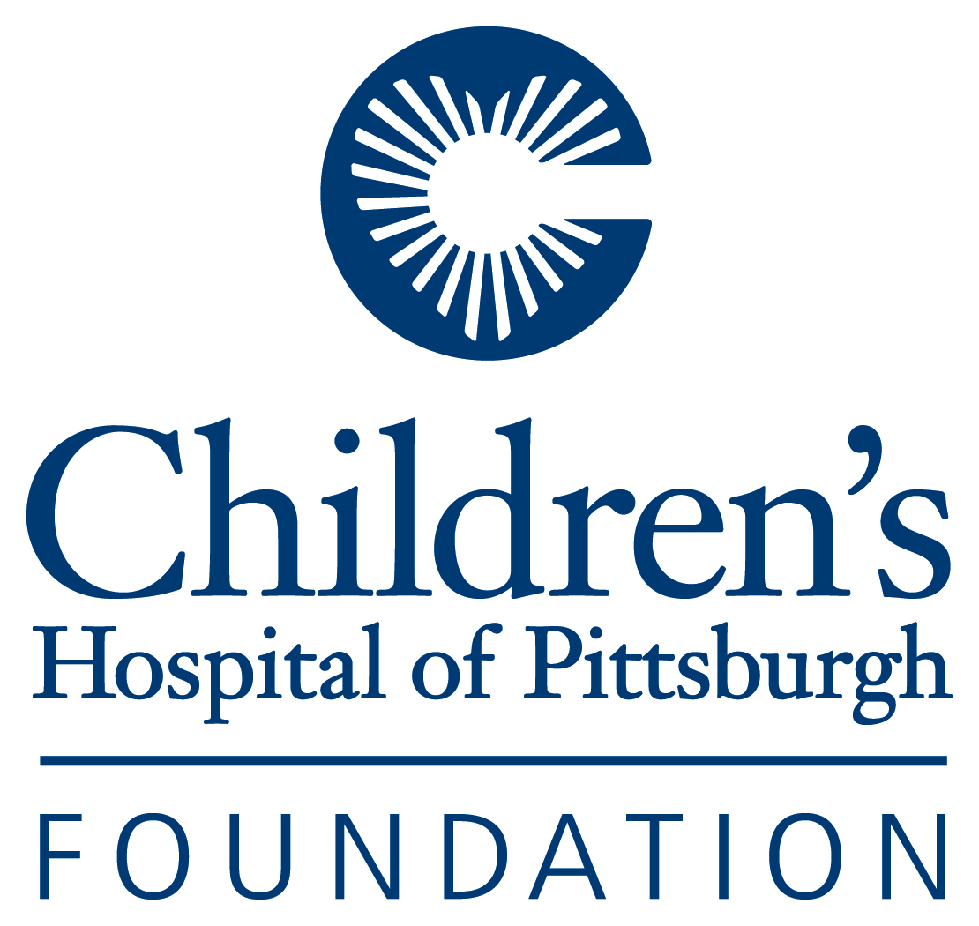

“Scramble” Format Phone: 724-934-2720

Treesdale Country Club

Monday

August 24, 2015

in partnership with

Children’s Hospital   
of Pittsburgh Foundation

* Birdie - $3,000
* Four golfers
* Signage on course
* Half-page program ad
* Golfer - $300

Includes greens fees, cart, practice range, registration gift bag, lunch, cocktail party, dinner, and all gratuities.

* Tee Sponsors: $250 for one tee sign

$350 for three tee signs

Your company name displayed at a tee where all golfers can see it.

* Dinner and Silent Auction Guest - $95
* Program Ads
* Full-page (5” wide x 8” high) $150
* Half-page (5” wide x 4” high) $100
* Business Card - $45
* I am unable to attend. Please accept my donation of $________________________.
* Double Eagle Presenting Sponsor - $10,000.00
* Co-presenter of outing with the Foundation
* Three golf foursomes
* Banner at registration table
* Banner at golf banquet
* Tee signage on all three courses
* Sponsor Recognition in golf program
* Full-page ad in golf program
* Eagle - $5,000.00
* Two golf foursomes
* Tee signage on all three courses
* Sponsor recognition in golf program
* Full-page ad in golf program

# Gigliotti Holdings

Golf Classic

for Children’s Hospital

of Pittsburgh Foundation

Monday, August 24, 2015

Treesdale Country Club

Please select from the following options:

All golfers receive:

Gift Bag

Lunch and Dinner

Greens Fees and Cart

All-Day Beverages

Other events:

Scramble Awards & Skill Prizes

Silent Auction

Chinese Auction

Live Auction

**Schedule**

10:00 a.m. Registration

10:00 a.m. Lunch Buffet

11:15 a.m. Shotgun Start

4:30 p.m. Cocktails

5:30 p.m. Tournament Banquet

Registration for “Scramble”

Company Name

Address

City State ZIP

Day Phone No.

Name of Team Leader Email:

Name of Team Member Email:

Name of Team Member Email:

Name of Team Member Email:

**Please make checks payable to Children’s Hospital of Pittsburgh Foundation and mail to:**

Gigliotti Holdings Golf Classic, 11279 Perry Highway, Suite 509, Wexford, PA 15090

**QUESTIONS?** Call 724-934-2720 **ENTRY DEADLINE:** August 14, 2015